PAYPAL PAYMENT INTAGRATION IN SPRING BOOT

* **Use Dependencies**

<dependency>

<groupId>org.springframework.boot</groupId>

<artifactId>spring-boot-starter-thymeleaf</artifactId>

</dependency>

<dependency>

<groupId>com.paypal.sdk</groupId>

<artifactId>rest-api-sdk</artifactId>

<version>1.4.2</version>

</dependency>

* **I refer the web Site**

[**https://www.sourcecodeexamples.net/2021/01/spring-boot-paypal-payment-gateway.html**](https://www.sourcecodeexamples.net/2021/01/spring-boot-paypal-payment-gateway.html)

* **I refer the video**

[**https://www.youtube.com/watch?v=GykDyG0ELms&t=1648s**](https://www.youtube.com/watch?v=GykDyG0ELms&t=1648s)

**PAYPAL SANDBOX CREDENTIALS**

* [**https://www.paypal.com/us/signin**](https://www.paypal.com/us/signin)

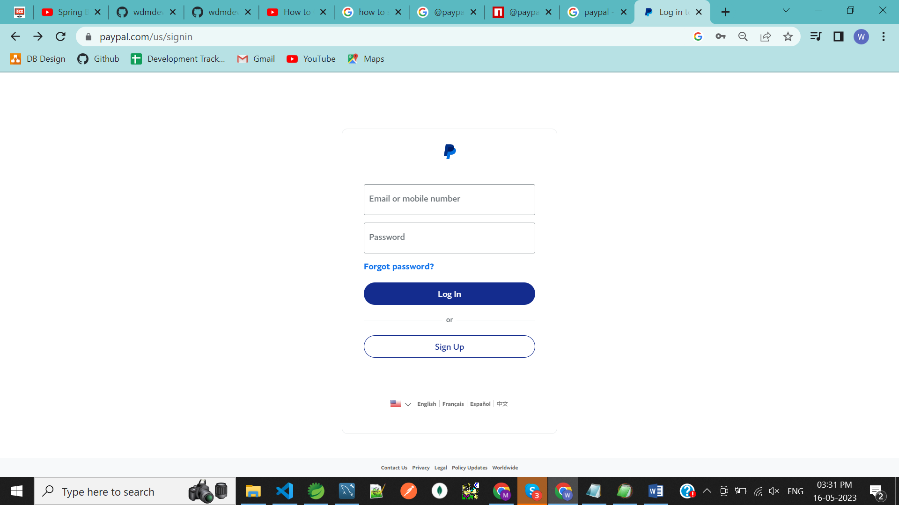

**STEP 1 : CLICK THE Sign Up**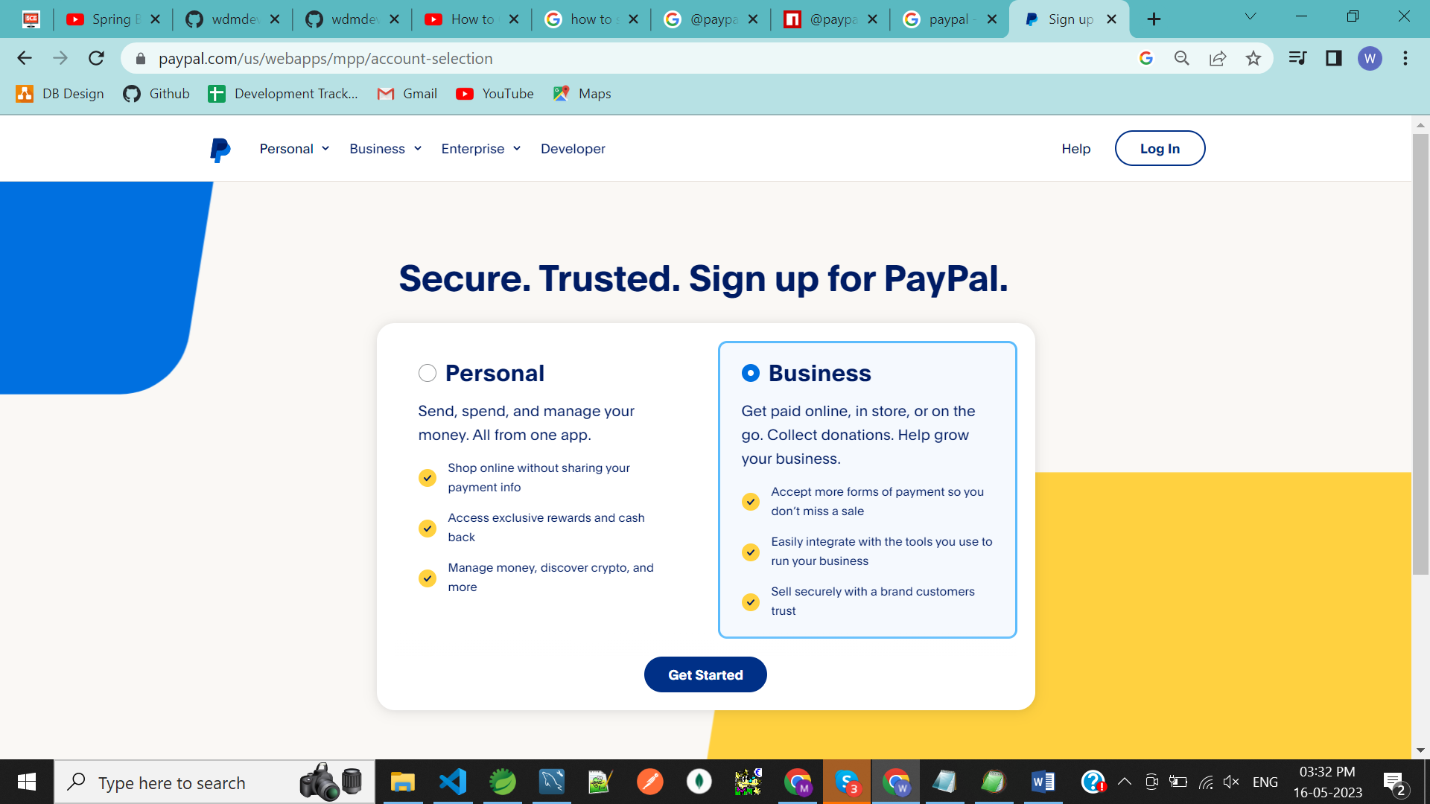

**STEP 2 : Create a business account**

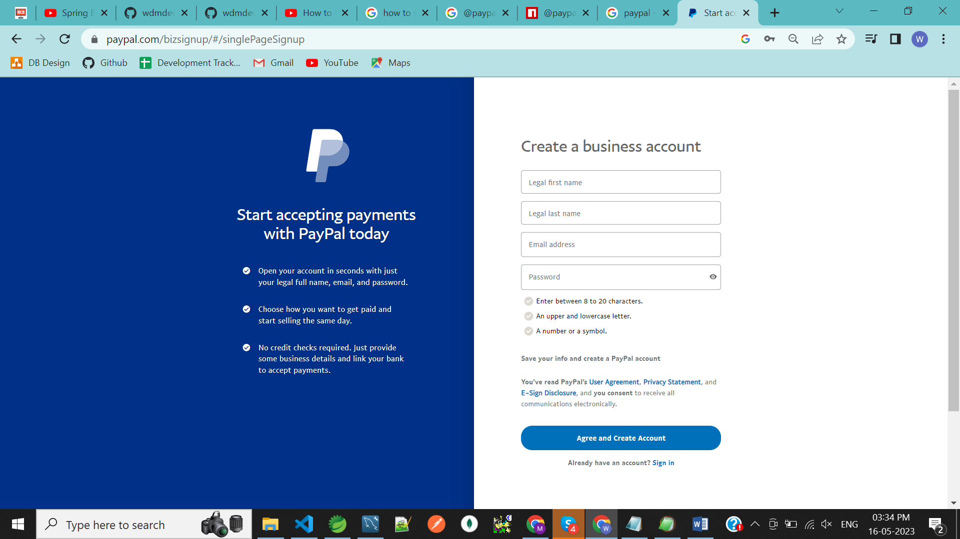

**STEP 3 : Then Login Home Page**

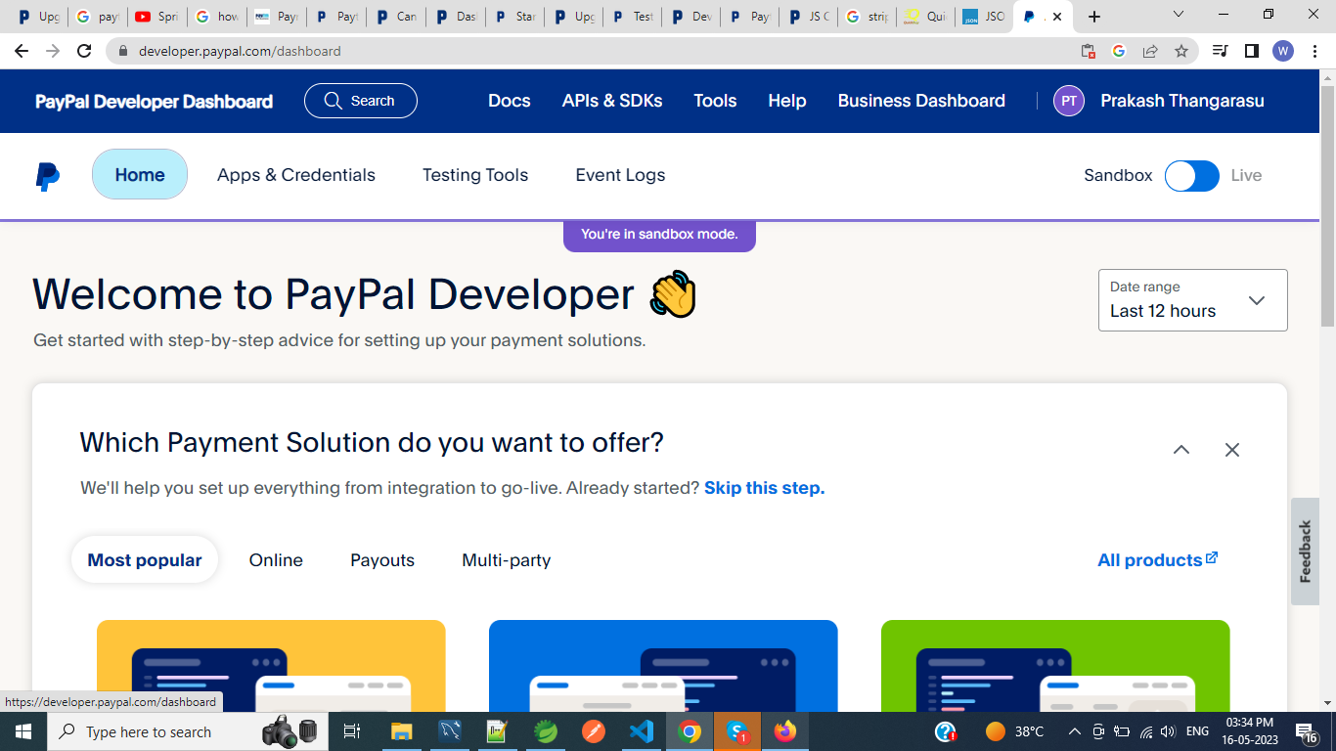

**STEP 4: Click on the Apps & Credentials**

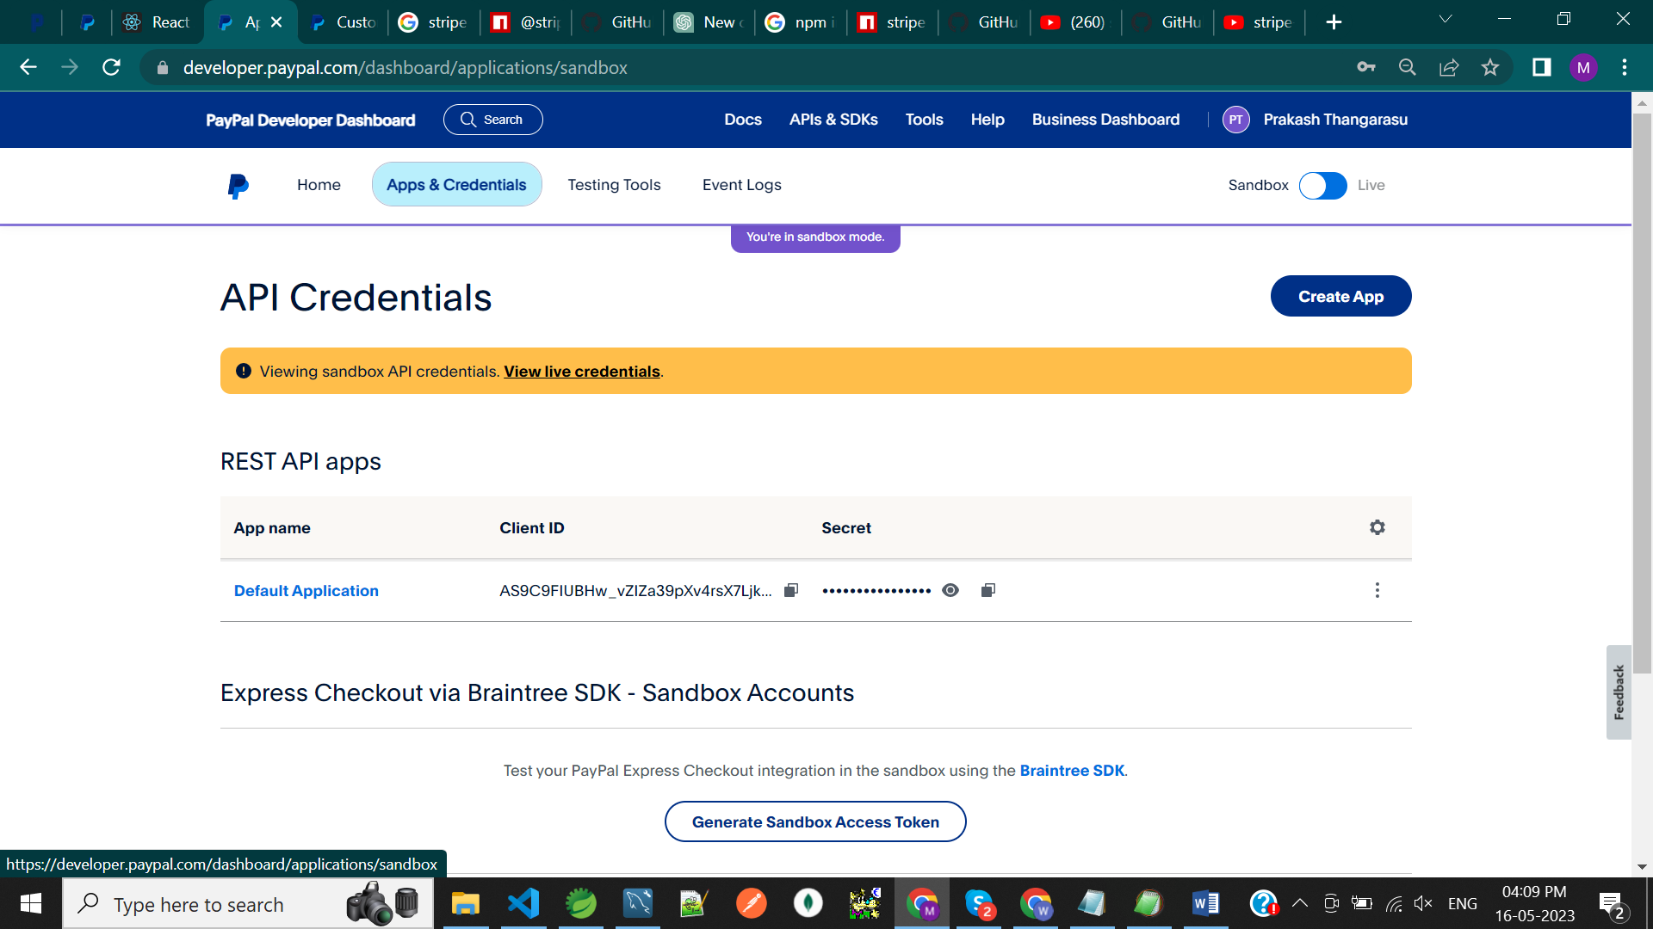

**Create An Sandbox Account**

**STEP 1: Click on the Testing Tools When Click Create account**

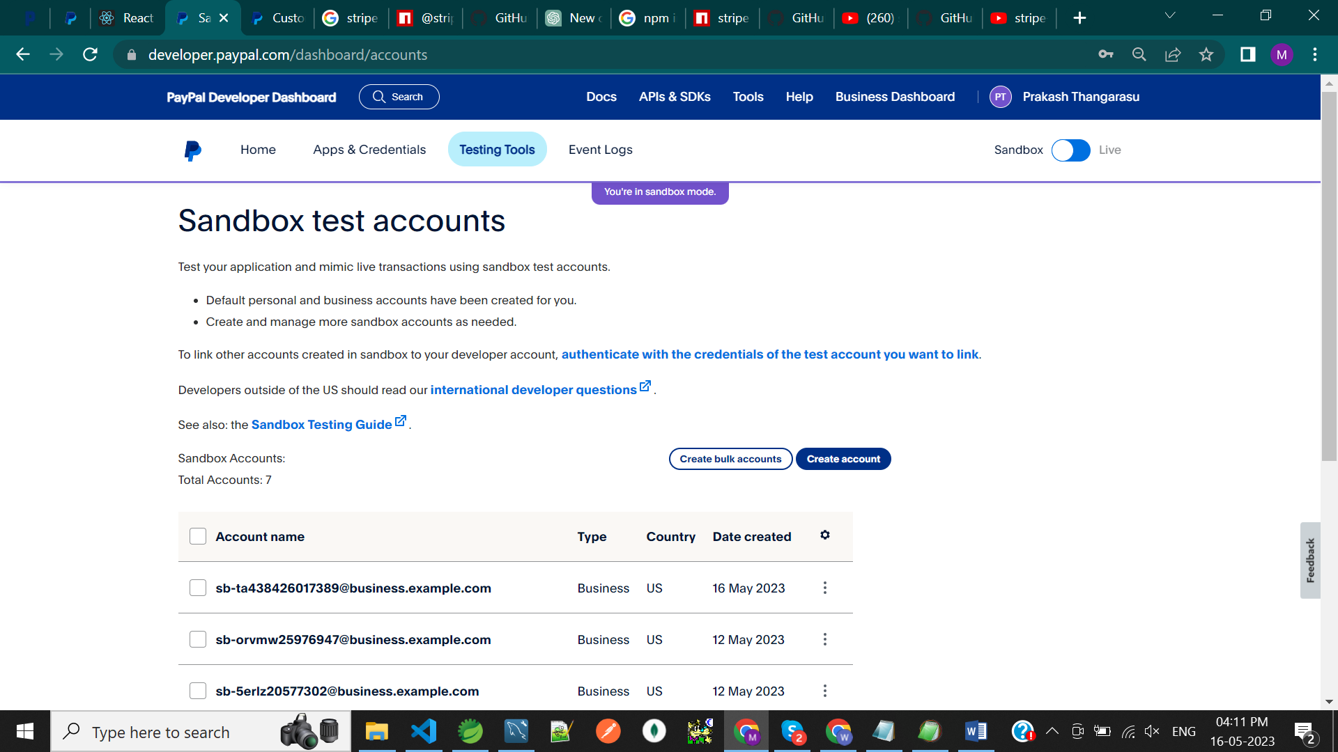

**Step 2 : then Create Sandbox Account**

**Account type : Business**

**Country / Region : don’t Select option India because government regulation. Buyers That have a billing address in India cannot use PayPal to make payment to sellers registered in india.**

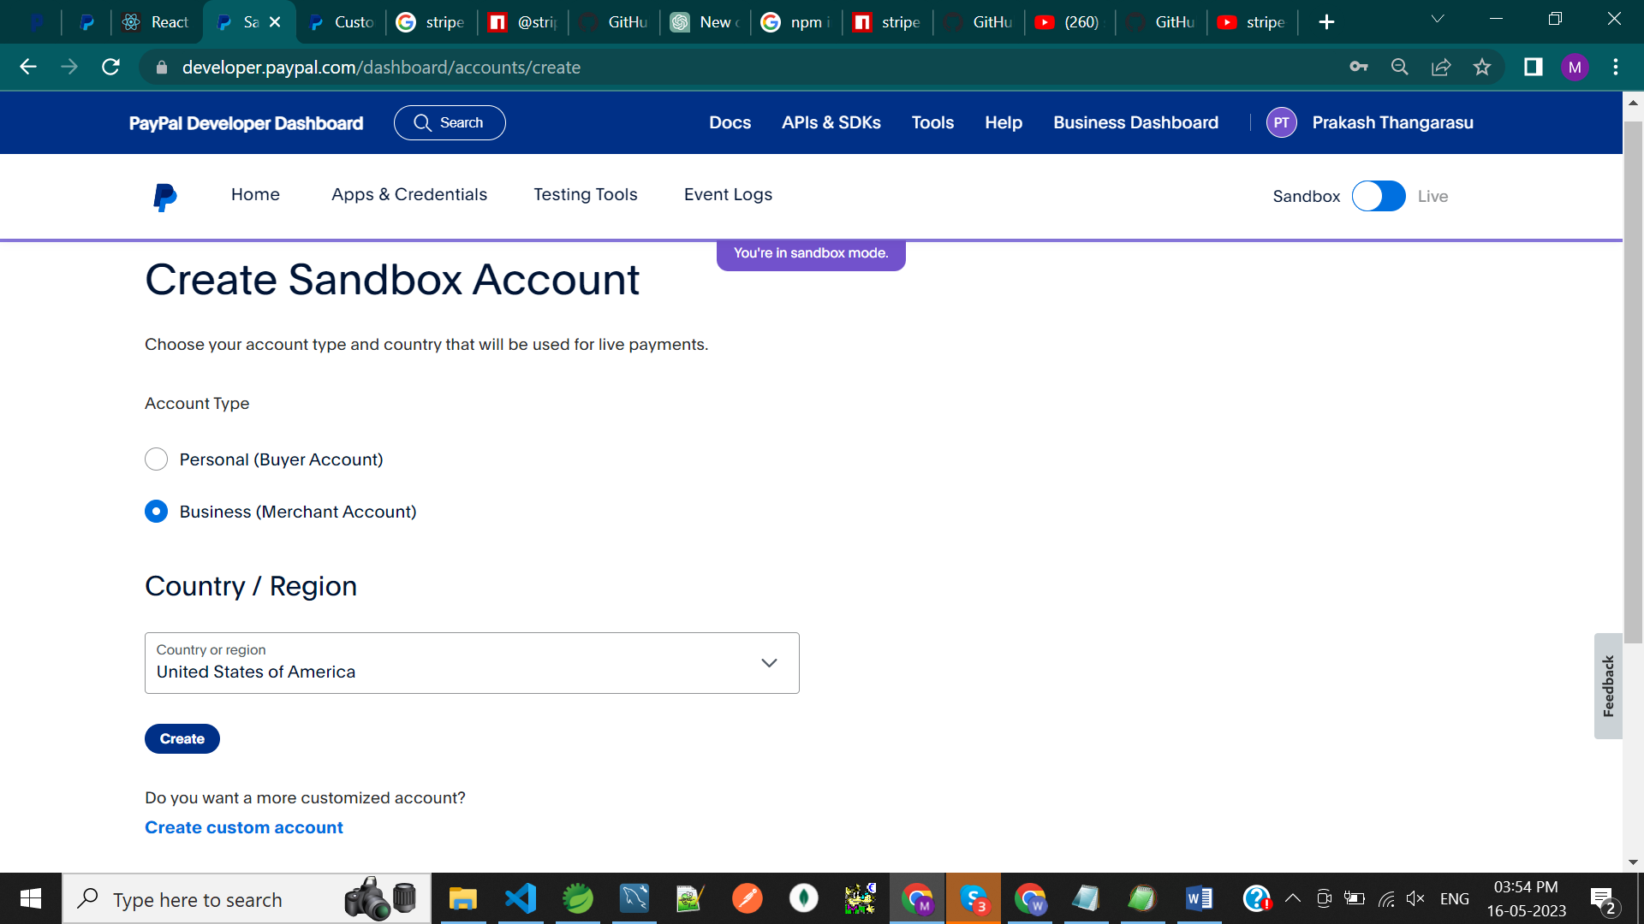

**STEP 3 : Click On The 3 dots**

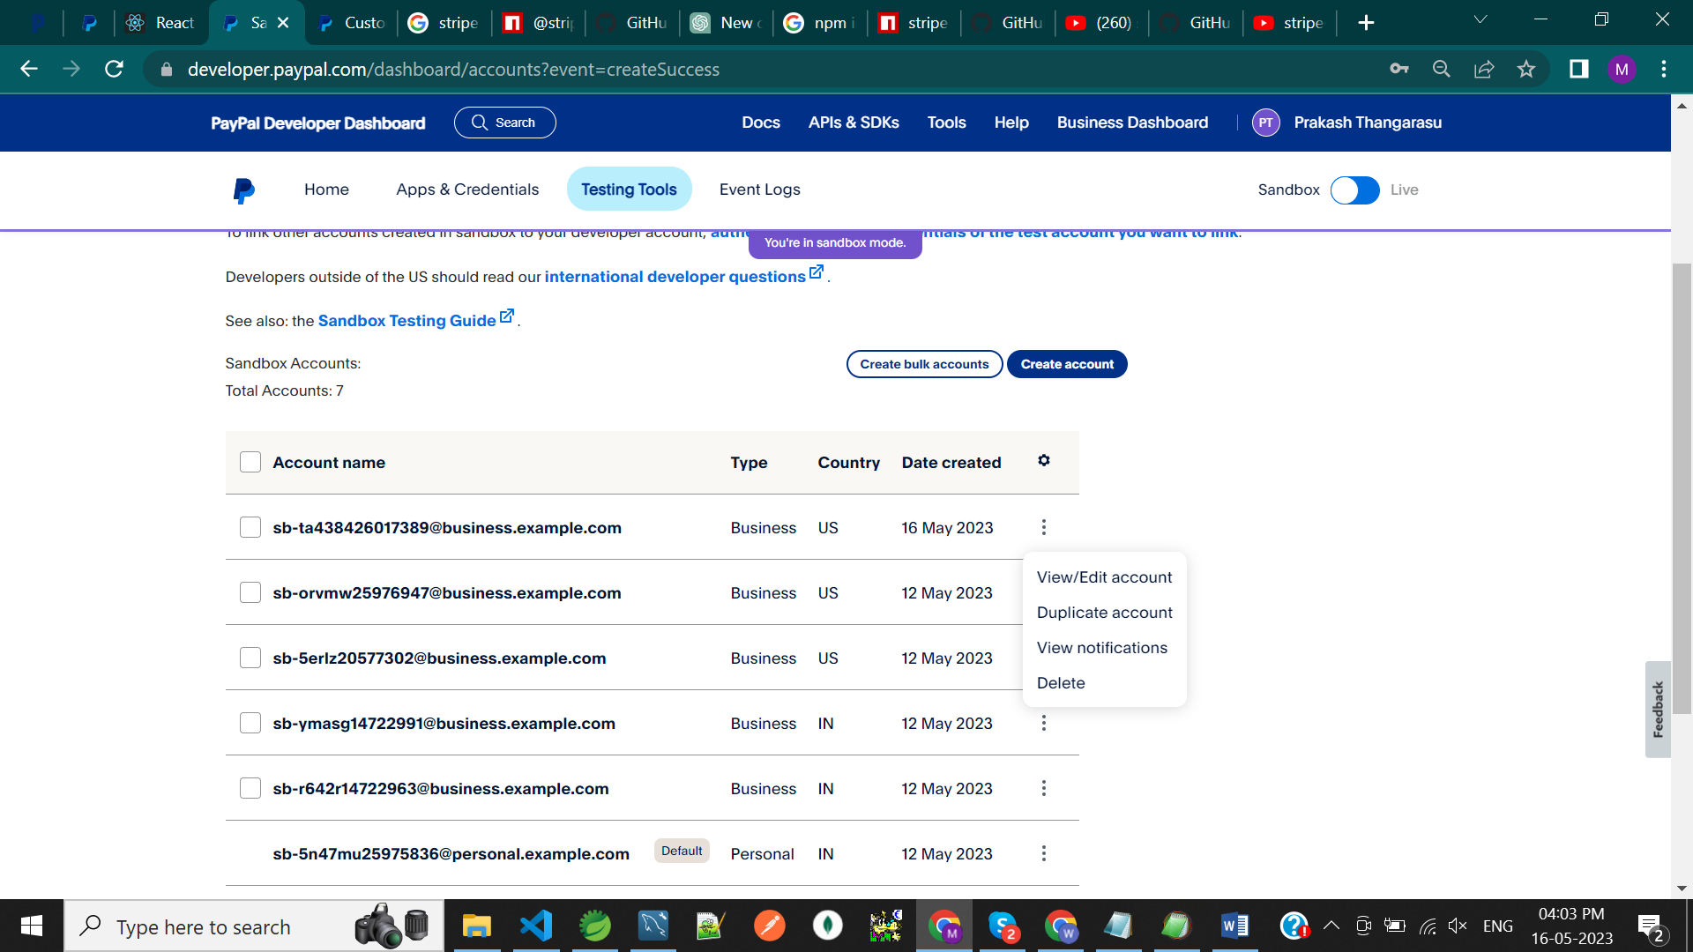

**STEP 4 : Then Click View/Edit Account When Show Account Details**

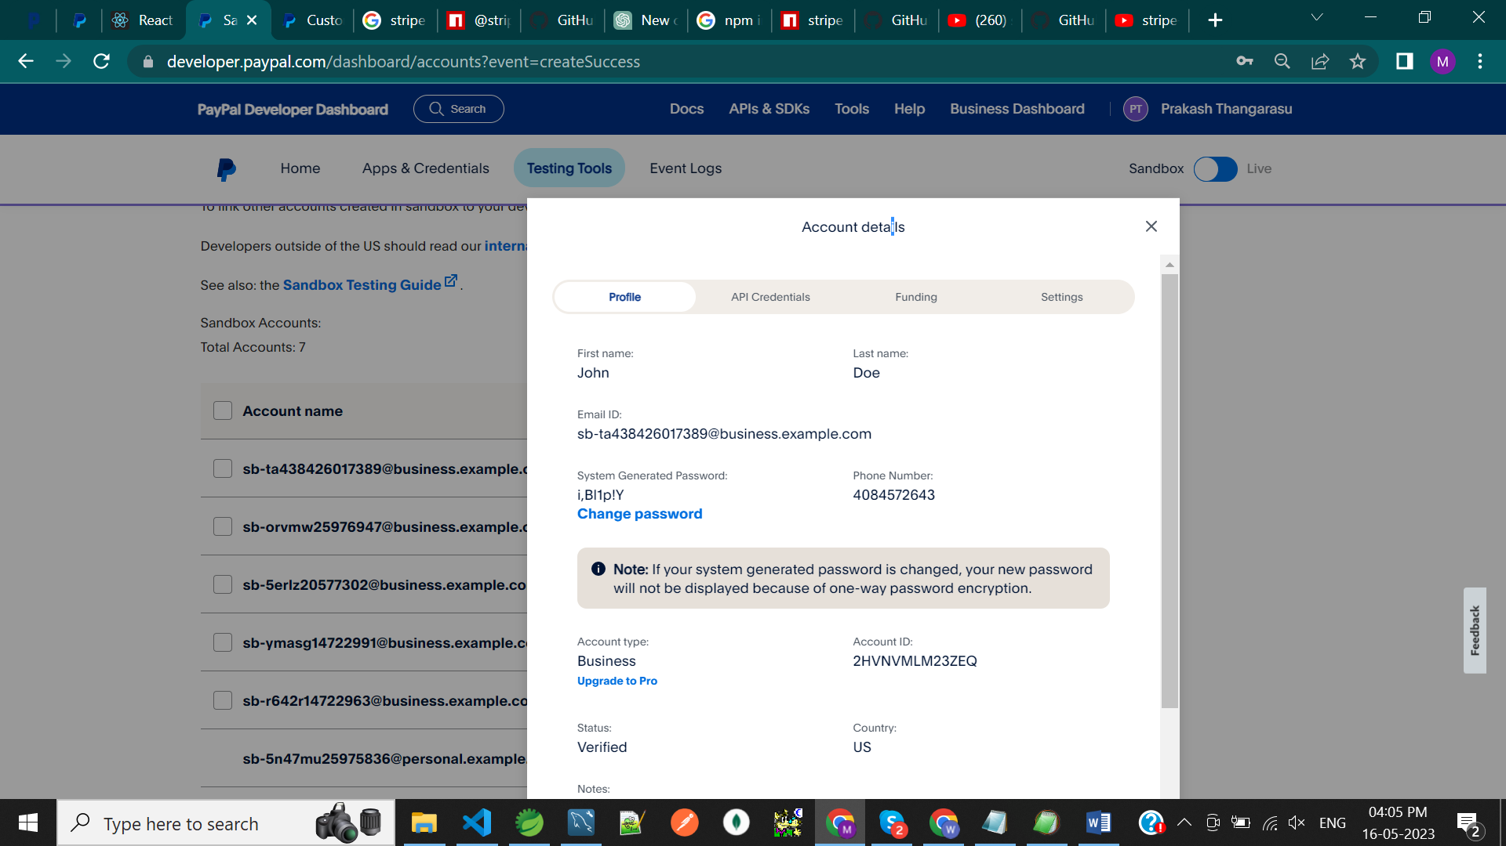

**STEP 5 : Finished Spring Boot Code When Start the Server Then Open Chrome open**

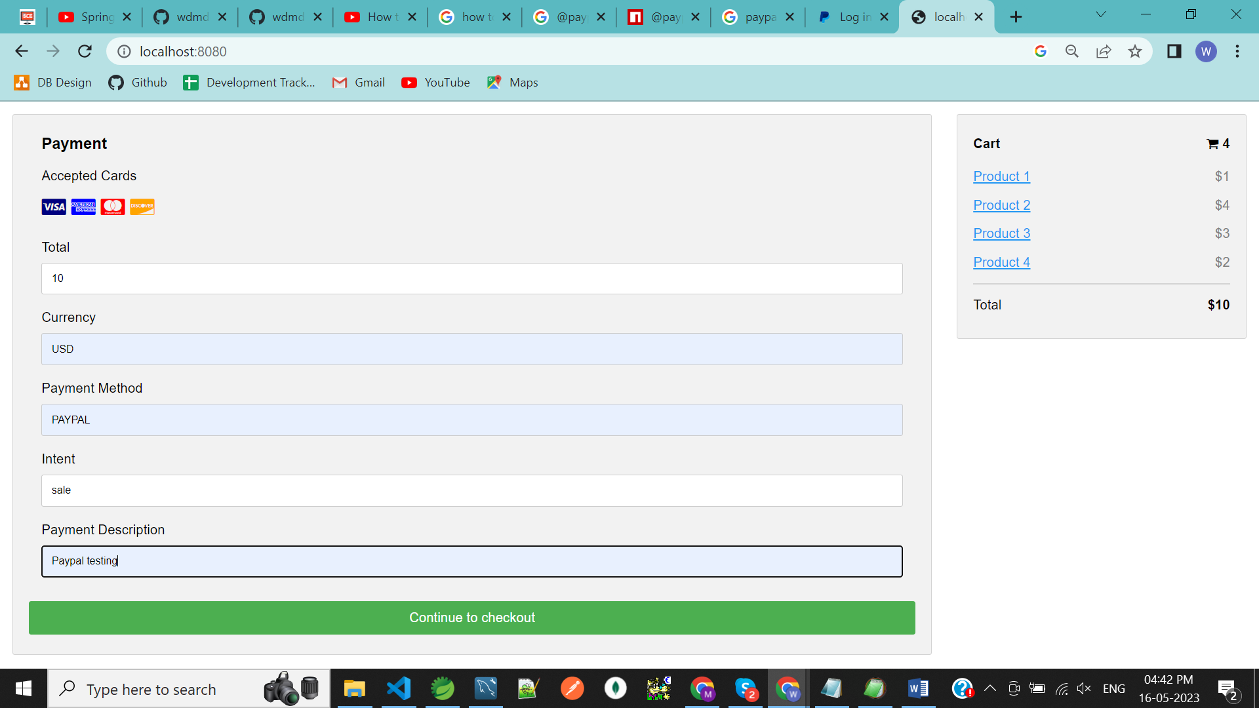

**STEP 6 : Then Click Continue to checkout button When Fill the Email And Password**



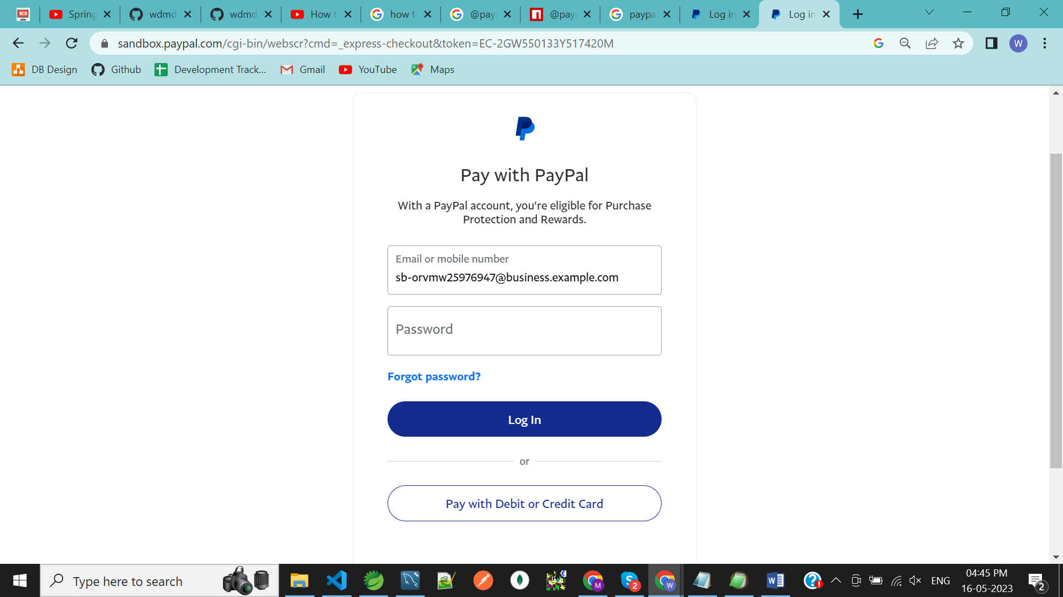

**STEP 7 : click on continue to Review Order**

